**VISVESVARAYA TECHNOLOGICAL UNIVERSITY**

**BELAGAVI-590018**



**AMINI PROJECT REPORT**

**ON**

**ORGAN DONATION SYSTEM**

**BY**

**H CHIRAG SHETTY JEEVAN KUMAR**

**(4MT19CS054) (4MT19CS061)**

*In the partial fulfilment of the requirement for 5th semester*

**DBMS LABORATORY WITH MINI PROJECT**

***Under the guidance of***

**Ms. Jyothi GN Ms. Roopitha CH**

**Assistant Professor Assistant Professor**



**Department of Computer Science and Engineering**

**(Accredited by NBA)**

**MANGALORE INSTITUTE OF TECHNOLOGY & ENGINEERING**

**Badaga, Mijar, Moodbidri-574225**

***2021-2022***

**MANGALORE INSTITUTE OF TECHNOLOGY & ENGINEERING**

**(An ISO 9001:2015 Certified Institution, Accredited by NAAC)**

**Badaga, Mijar, Moodbidri-574225**

DEPARTMENT OF COMPUTER SCIENCE AND ENGINEERING

**(Accredited by NBA)**

CERTIFICATE

This is to certify that Mr/Miss **STUDENT NAME(4MT…..)** has satisfactorily completed the mini project entitled “**Project Title”** for the **DBMS Laboratory with mini project(18CSL58)**lab as prescribed by the VTU for 5th semester B.E. Computer Science and Engineering branch for the academic year 2021 – 2022.

|  |  |  |  |
| --- | --- | --- | --- |
| **…………………………** | **…………………………** |  | **…………………………** |
| **Ms. Jyothi GN** | **Ms. Roopitha CH** |  | **Mr. Ravinarayana B** |
| **Assistant Professor** | **Assistant Professor** |  | **Associate Professor & HOD** |
| **MITE, Moodabidri** | **MITE, Moodabidri** |  | **MITE, Moodabidri** |
|  |  |  |  |

**Signature of the Examiners**

1. **…………………………..**
2. **…………………………..**

**ABSTRACT**

The main aim of Organ Donation Management system keeps records of donor’s, hospital, doctors and the attorney details. Through this project we would like to demonstrated create, read, update and delete SQL operations. At first the donor or the doctor is provided different options like to add their details, power of attorney of the donor can login using donor’s login id and add his details, doctor can add organ details. The donor and doctor also can update the entered details. This allows us to record the donation process. The interfaces for organ donation management system have been designed according to the requirement and needs of the current market rather than that, this system also has been tested and evaluated in real life. This Organ Donation Management system will help to improve the performance of current situation and overcome the problems that arise nowadays. The Online Organ Donation Management System is developed mainly for general hospitals (GH), clinics and other health centres to manage the donor registration and user maintenance. The public can retrieve information about organ donation in this web site. People who interested can register themselves through this system. The application will be processed by the administrator and each donor will receive feedback about their application status. Furthermore, the authorized user’s account will be maintained by the administrator. The donor record will be managed by four main users such as administrator, doctor, medical assistant and management staﬀ. Only administrator, doctor has the authority and privileges to print organ list report and total donation report according to district from this system. The methodology of this system is Structured System Analysis and Design. An analysis study has been done based on the current manual system and all the problems statements and requirements have been identiﬁed. Moreover, Organ donation management system is three tier architecture system which involves client tier, business tier and database management tier. The interfaces for Organ donation management system have been designed according to the requirement and needs of the current market Rather than that, this system also has been tested and evaluated in real life.

# 

ACKNOWLEDGEMENT

The successful completion of any significant task is the outcome of invaluable aggregate combination of different people in radial direction explicitly and implicitly. We would therefore take opportunity to thank and express our gratitude to all those without whom the completion of project would not be possible.

We express our thanks to …………… [GUIDE and HOD]

We are grateful to ………………

We would also wish to convey our profound thank to lab assistants, non-teaching staff, and parents who directly or indirectly helped us in make project successful.

**STUDENT NAME**

Table of Contents

**Abstract…………………………………………………………i**

**Acknowledgement………………………………………………ii**

**1. INTRODUCTION 6**

**1.1 Problem Statement 6**

**1.2 SQL 6**

**1.3 PHP 7**

**1.4 HTML5 7**

**1.5 CSS3 7**

**2. ANALYSIS and REQUIREMENTS SPCIFICATION 8**

**3. SYSTEM DESIGN 9**

**3.1: ER DIAGRAM 9**

**3.2: SCHEMA DIAGRAM 11**

**3.3: BLOCK DIAGRAM 12**

**3.4: FLOW CHART 14**

**4. IMPLEMENTATION 16**

**6. TESTING 17**

**7. SNAPSHOTS 18**

**8. CONCLUSION 19**

**9.REFERENCE 20**

# 1. INTRODUCTION

The Organ donation is a website which is made for a particular hospital. The Organ donation system provides donor registration, doctor registration, view the newly added record, record history and details of power of attorney, organ details. The main aim of making this system is to provide people a way to donate their organs after death and to help other people who are in need of organs. This report discusses the result of the work done in development of "Websites for Organ donation on "HTML" and "CSS" Front-end Platform and “My SQL” as back-end Platform. At the development of an application PHP provides a good connecting facility between all pages, also the back-end MySQL is most important to save all the data related the application. The deﬁnition of our problem lies in manual system and a fully automated system. MANUAL SYSTEM: The system is very time consuming and lazy. This system is more prone to Errors and sometimes the approaches to various problems are unstructured. TECHNICAL SYSTEM: With the advent of latest technology if we do not update our system then our business results in losses gradually with time. The technical systems contain the tools of latest Trend i.e. computers printers, fax, Internet etc. The systems with this technology are very fast, Accurate, user-friendly and reliable. To promote organ donation for transplantation as a treatment for many life-threatening diseases including heart disease, kidney disease, liver disease, diabetes and cystic ﬁbrosis. To educate and inform the community, patients and their families and health professionals about organ and tissue donation to markedly improve rates of donation. To work in partnership with Department of Health (DOH), clinicians, and hospitals to promote best practice professional training and ensure that the family of every potential donor is oﬀered the option of donation in a caring and respectful manner. To provide support, care, information and advocacy for people and with end stage organ failure, donor families, living donors transplant recipients and their families.   
Assuring compliance with all external regulatory bodies, including but not limited to: the Organ Procurement and Transplantation Network (OPTN), the United Network for Organ Sharing (UNOS), Centres for Medicare and Medicaid Services (CMS) Conditions of Participation (COP), the Missouri State Department of Health (DOH), The Joint Commission (TJC) Standards.

## Problem Statement

To develop a web application that would store the details of donors and the doctor’s performing operation and also making the database available to only authorized personnel.

## SQL

SQL (Structured Query Language) is a standardized programming language that's used to manage relational databases and perform various operations on the data in them. Initially created in the 1970s, SQL is regularly used not only by database administrators, but also by developers writing data integration scripts and data analysts looking to set up and run analytical queries. The uses of SQL include modifying database table and index structures; adding, updating, and deleting rows of data; and retrieving subsets of information from within a database for transaction processing and analytics applications. Queries and other SQL operations take the form of commands written as statements -- commonly used SQL statements include select, add, insert, update, delete, create, alter and truncate.

## PHP

**PHP** is general purpose scripting language geared towards web development. It was originally created by Danish-Canadian programmer Rasmus Lerdorf in 1994. The PHP reference implementation is now produced by The PHP Group. PHP code is usually processed on a web server by a PHP interpreter implemented as a module, a daemon or as a Common Gateway Interface (CGI) executable. On a web server, the result of the interpreted and executed PHP code – which may be any type of data, such as generated HTML or binary image data – would form the whole or part of an HTTP response. Various web template systems, web content management systems, and web frameworks exist which can be employed to orchestrate or facilitate the generation of that response. Additionally, PHP can be used for many programming tasks outside the web context, such as standalone graphical applications and robotic drone control. PHP code can also be directly executed from the command Line.

## HTML5

HTML5 is a markup language used for structuring and presenting content on the World Wide Web. It is the fifth and last major HTML version that is a World Wide Web Consortium (W3C) recommendation. The current specification is known as the HTML Living Standard.

## 1.5 CSS3

Cascading Style Sheets (CSS) is a language that is used to illustrate the look, style, and format of a document written in any markup language. In simple words, it is used to style and organize the layout of Web pages. CSS3 is the latest version of an earlier CSS version, CSS2.A significant change in CSS3 in comparison to CSS2 is the introduction of modules. The benefit of this functionality is that it allows the specification to be finalized and accept faster, as segments are finalized and accepted in portions. Also, this allows the browser to support segments of the specification.

# 2. ANALYSIS and REQUIREMENTS SPCIFICATION

# 

# 3. SYSTEM DESIGN

## 3.1: ER DIAGRAM

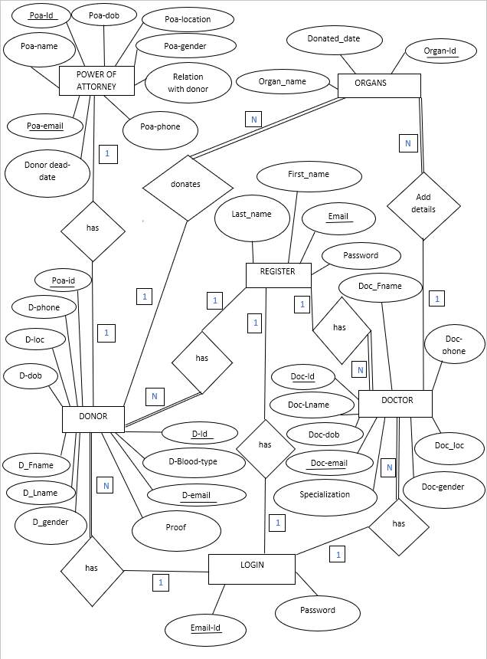

Consider, in the donor relation the D-Id, D-email and Poa-id are the primary keys. D-email is also a foreign key which references Email-Id of the login relation when having the relation with login and it references Email of Register relation when having the relation with Register relation. There is 1: N type relation between donor and login i.e., one login has N donors. There is 1: N type relation between register and donor i.e., one register has N donors. In the Register relation Email is the primary key. In the login relation Email -Id is the primary key, but it is also the foreign key which references Email of Register relation. There is 1:1 type relation between register and login i.e., one Register has one login. In the Organ relation, consider Organ-Id as the primary key and D-Id is the foreign key in that relation. There is 1: N type relation between donor and organ i.e., one donor can donate N organs. Doc-Id is also the foreign key in organ relation.

Consider doctor id and doctor email to be primary key in the doctor relation. Doc-email along with primary it is also a foreign key which references Email-Id of login relation when having relation with login and it also references Email of Register relation when having relation with Register. There is 1: N type relation between Doctor and Register i.e., one register has N Doctors. There is 1: N type relation between login and Doctor i.e., one login has N Doctors. There is 1: N type relation between Doctor and Organ i.e., one doctor can add details of N organs.

**3.2: SCHEMA DIAGRAM**

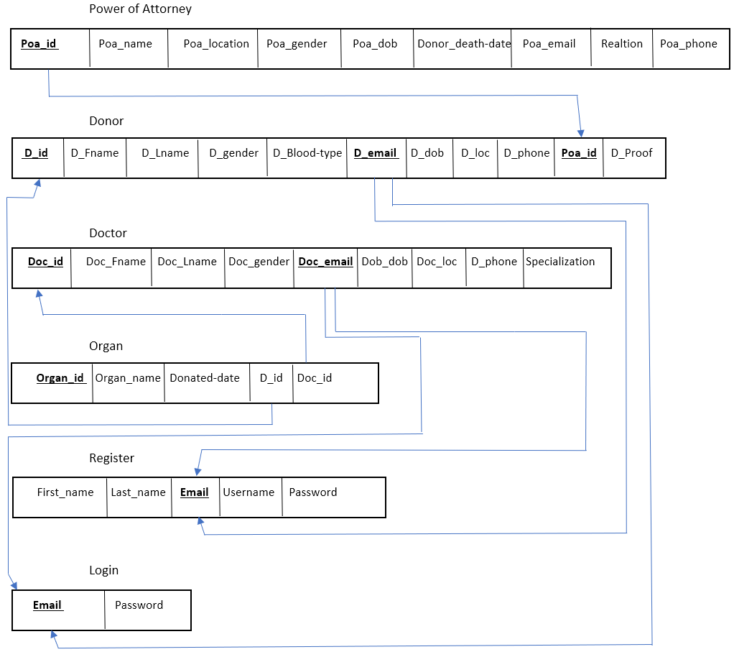

## 3.3: BLOCK DIAGRAM

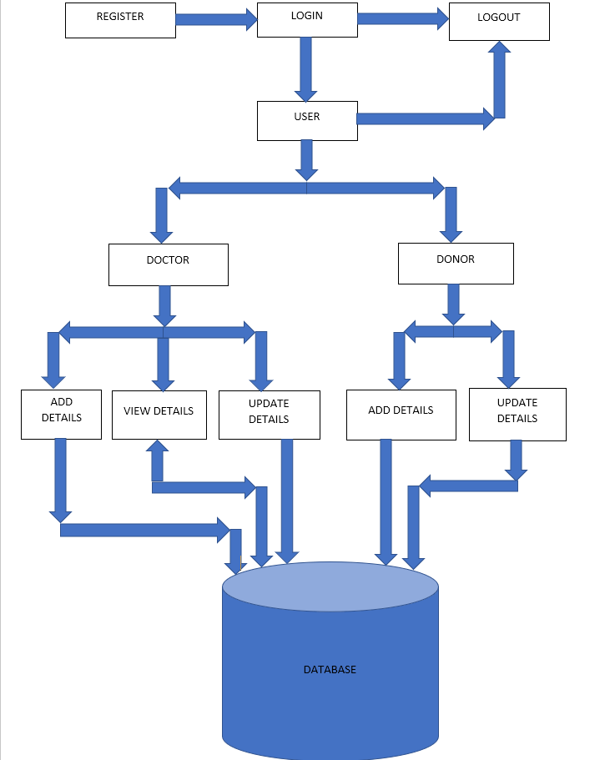

The donor will first register and then login using his username and password the donor is the redirected to the page where he can fill all of his/her detail he can also update his/her details which will enable the hospital to get the information about the donor. Similarly, the doctor will first register and then login using his username and password the donor is the redirected to the page where he can fill all of his/her detail he can also can update his/her details, he can fill organ details as well as update it. Doctor can view the donor details, power of attorney details, organ details and other doctor details. The donor and the Doctor can logout using logout button.

## 3.4: FLOW CHART

**Start**

Register

Login

Check

**False data**

**True**

Doctor

Donor

Adds detail

Update details

Add detail

Update detail

Views

Submits

Save

Logout

**Stop**

The donor and the doctor can register to the organ donation website and the login. The login using their username and password the system checks the username and password and then if the entered username or password is correct then it allows access to the user and then he or she can add detail update and the doctor can also view the donor detail and then they can logout of the system.

# 4. IMPLEMENTATION

# 5. TESTING

# 6. SNAPSHOTS

# 7. CONCLUSION

# 8. REFERENCES